**Linux Introduction**

1. **What is Linux?**

Linux is an open-source operating system like other operating systems such as Microsoft [Windows](https://www.javatpoint.com/windows), Apple Mac OS, iOS, Google android, etc. An operating system is a software that enables the communication between computer hardware and software.

1. **Why we use Linux?**

* Free O/S
* Open Source
* Secure
* Distributions
* Fast Performance

1. Flavours in Linux?

* RHEL
* CentOS
* SUSE
* Oracle Linux
* Fedora

1. What is Kernel?

The heart of the operating system, the kernel controls the hardware and turns part of the system on and off at the programmer’s command. If you ask the computer to list all the files in a directory, the kernel tell the computer to read all the files in that directory from the disk and display them on your screen.

1. Types of Shell?

A shell is a program that acts as an interface between the user and the operating system (OS) kernel.

* The Bourne Shell
* Bash Shell
* C Shell
* Korn Shell
* Z Shell
* Fish Shell

1. Difference between Windows, Linux and Unix?

|  |  |  |
| --- | --- | --- |
| Linux | Unix | Windows |
| Open Source | Not a Open Source | Not a Open Source |
| Command line Interface | Graphical user Interface | Graphical user Interface |
| Multi User, Multi Tasking | Multi User, Multi Tasking |  |
| Free O/S | Not a Free O/S | Not a Free O/S |

1. Why Root?

The root user is the powerful system admin user and also called as a Linux superuser. They can, quite literally, do anything. Nothing is restricted or off-limits for Root.

If you are login as a normal user you will be having limited permissions.

1. Filesystem Hierarchy?

It defines the directory structure and directory contents in Unix-like operating systems.

/ This is top level directory.

It is parent directory for all other directories.

It is called as a root directory.

/root It is home directory for root user (Super user).

/home It is home directory for other users.

/boot It contains all bootable files for Linux.

/etc It contains all configuration files

/usr By default soft wares are installed in this directory

/opt It is optional directory for /usr

It contains third party soft wares

/bin It contains commands used by all users(Binary Files)

/sbin It contains commands used by Super user

/dev It contains device files

/proc It contains process files

It is also called as Virtual Directory

/var It containing variable data like mails, log files.

/mnt It is default mount point for any partition

By default it is empty

/media It contains all removable media like CD ROM, Pen drive

/lib It contains library files which are used by OS

/tmp It is a temporary area of all users to utilize

**Basic Commands**

1. To list out the file and directories?

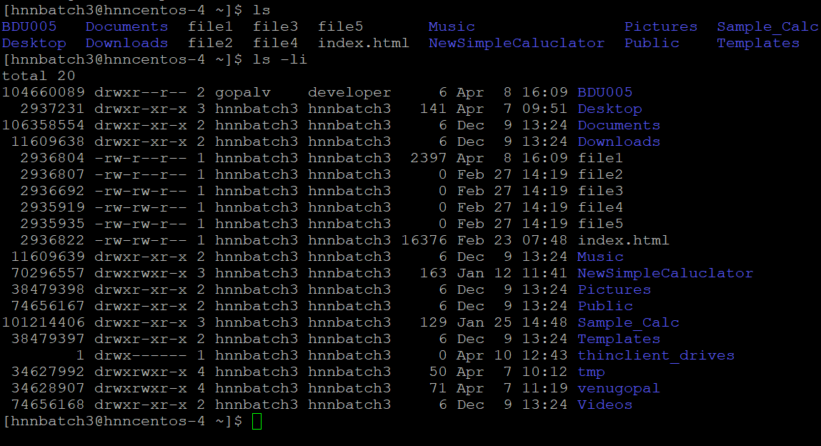

1. **Create a Directory?**

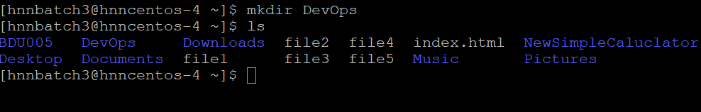

**PWD**

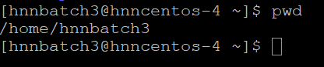

**Copy**

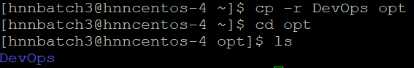

**Remove**

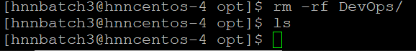

**CAT**

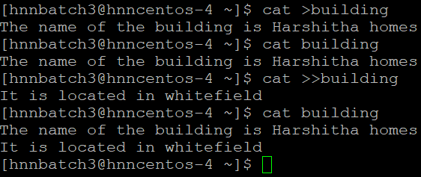 **HEAD**

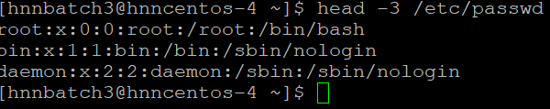 **Vi Editor**

It will create file in editor mode, enter new data and change existing data.

Command

Vi file3 -----> It will open the editor mode

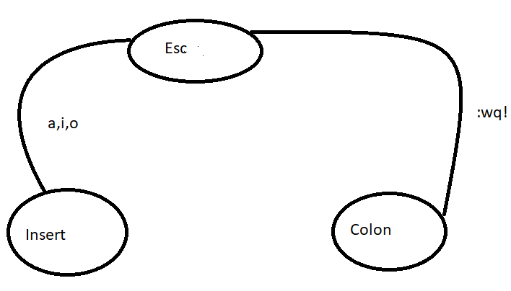

To edit and enter text : a,I,o

To exit and vi and save changes: ZZ or :wq!

**File Permissions**

**CHMOD**

Permissions can be set on any file/Dir by two methods

1. Symbolic method(ugo) # chmod g-x BDU005
2. Absolute method(numbers) #chown 754 BDU005



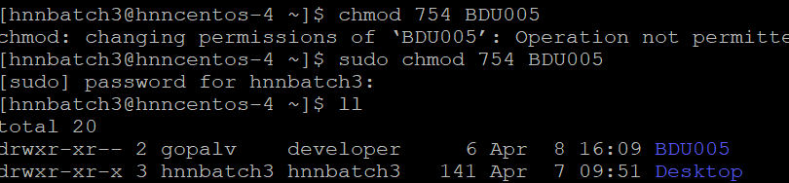

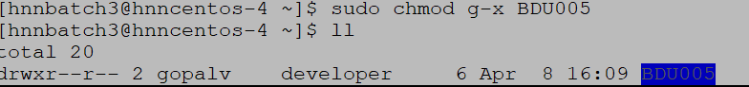

**CHOWN**

**#chown <username>:<groupname>**



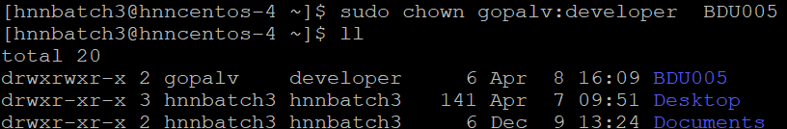

**PIPE, GREP, SED, CUT, AWK,FIND**

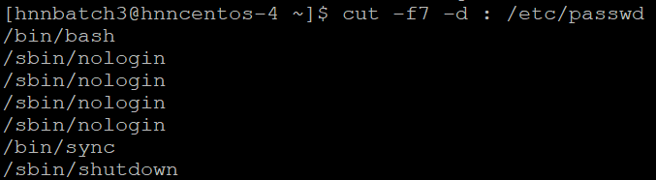

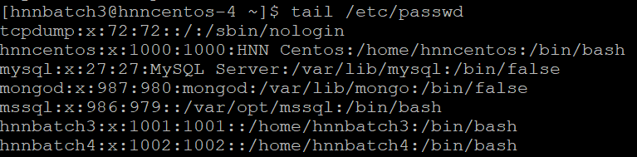

**AWK**

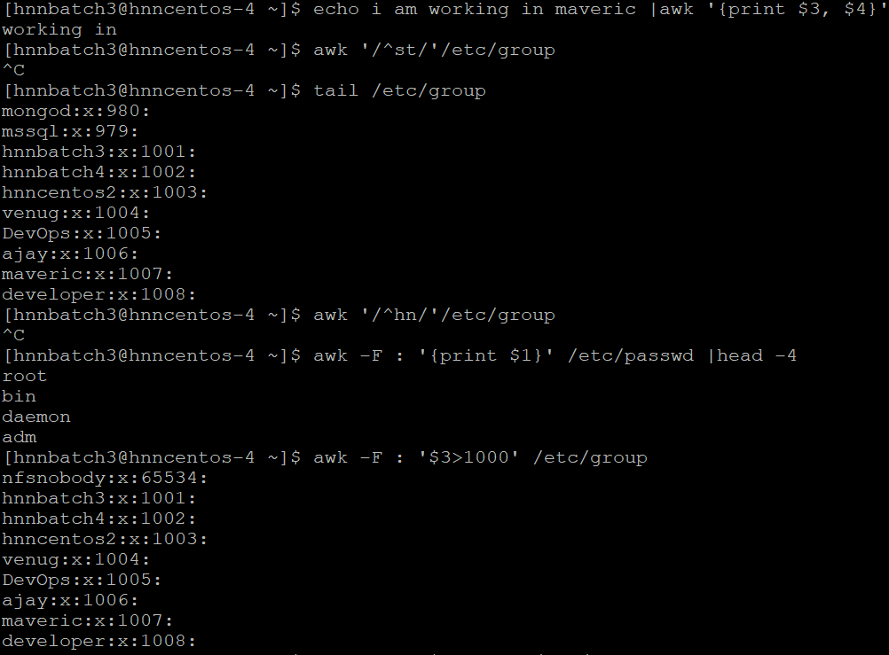

**TAIL**

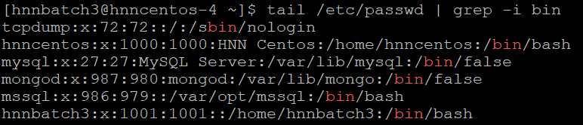 **SED**

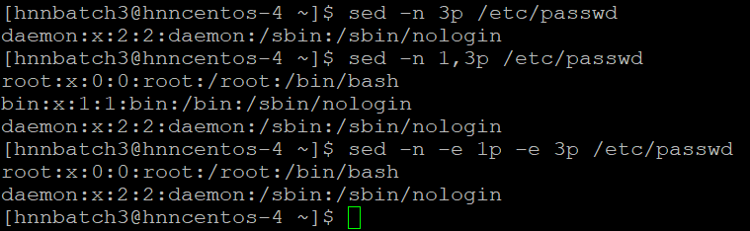

**Hard ware related Commands**

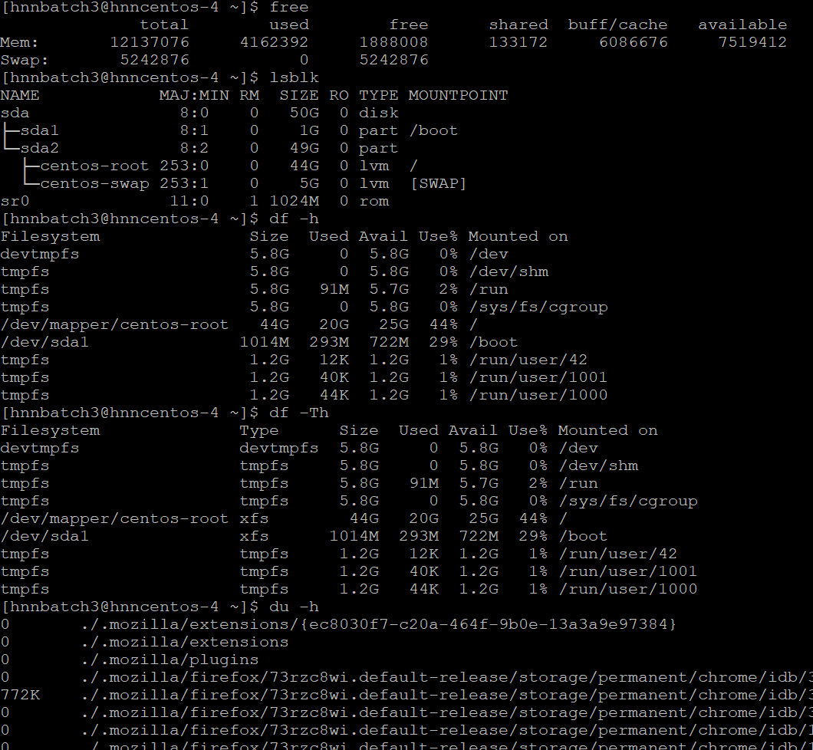

**SAR—System activity report**

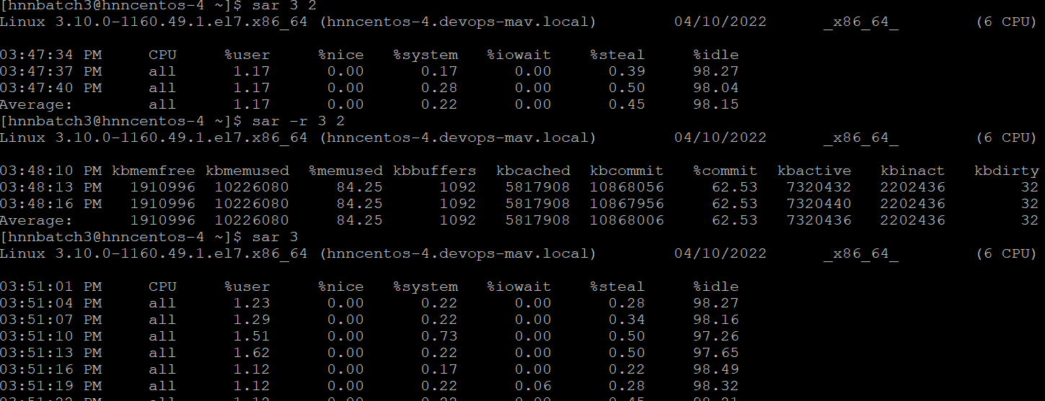

[hnnbatch3@hnncentos-4 ~]$ **top**

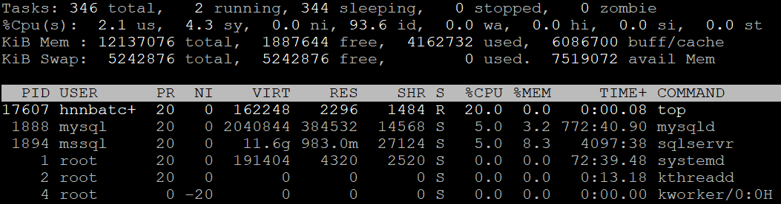

**PS**

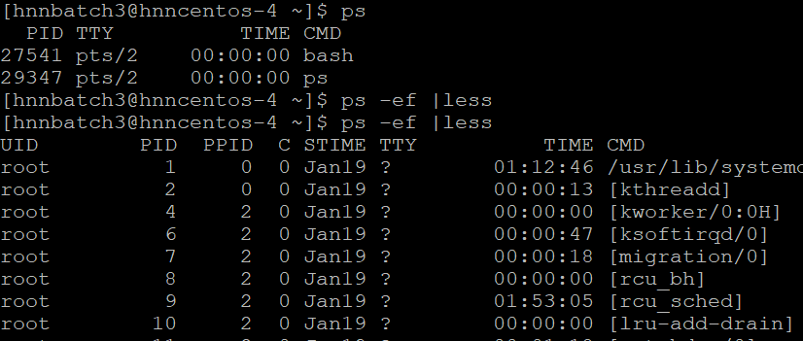

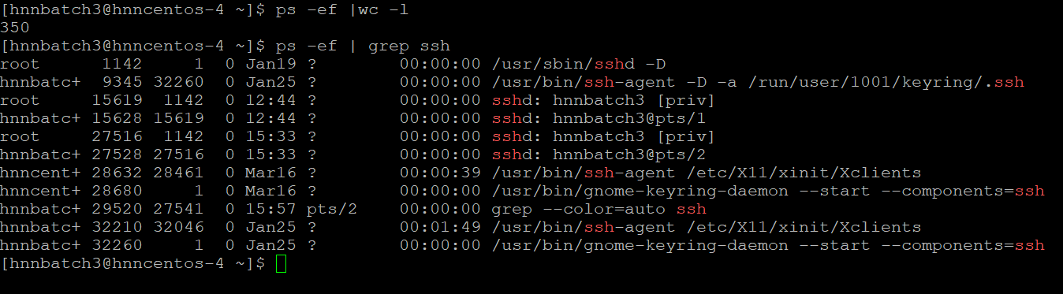

**KILL**



**ISOF – List all open files**

**To list out all opened file**

**#sudo isof**

**For word count**

**#sudo isof |wc -l**

**To check for particular user how many files are opened**

**#sudo isof -u <username>**

**Ping**

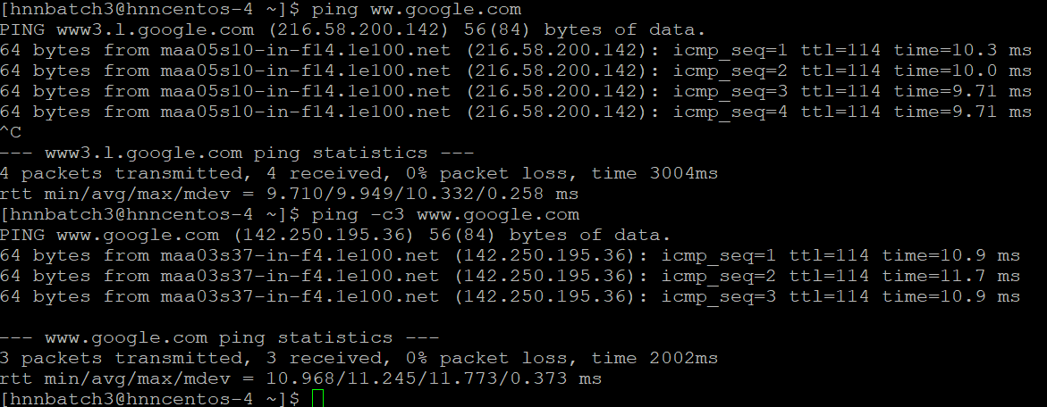

**Netstat**

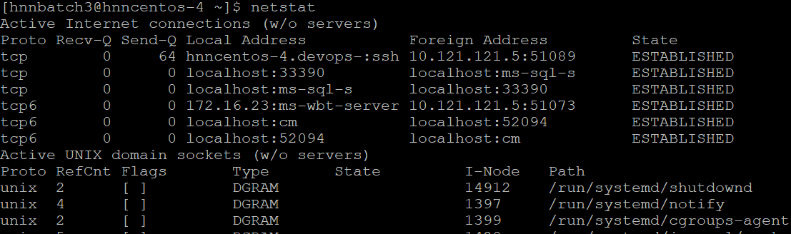

**Iptables**

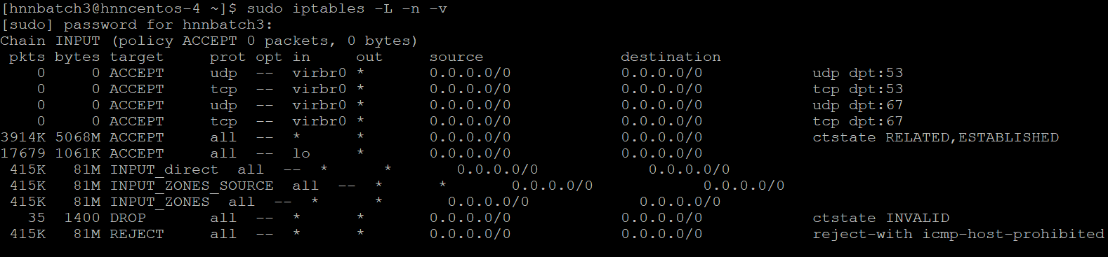

**Route**—Gives routing table information

**#route**

**To add default gateway**

**#route add default gw <gateway IP>**

**To add the network**

**#route add -net <IP address> gw <gateway IP>**

**#wget**-- Download file from network

**#ftp** --- Connect remote ftp host

**#arp**---- Check ethernet connectivity and IP address

**#nslookup** ---- Check domain name and IP information

**#traceroute**--- Trace existing network

**NMCLI**

To see network connections and interfaces

#nmcli dev status

To see more details of your connection

#nmcli connection show –active

To see device network type

#nmcli device show |head -10

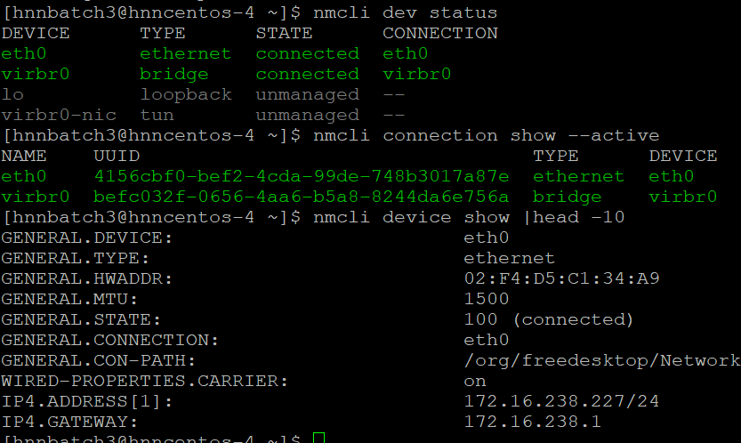

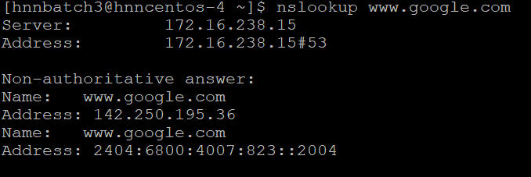 **To create a new user**

**#useradd <username>**

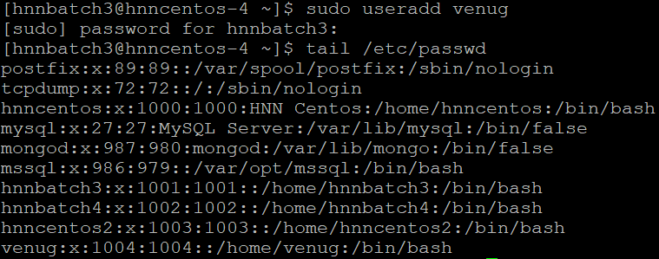

**To Create group**

**#groupadd <groupname>**

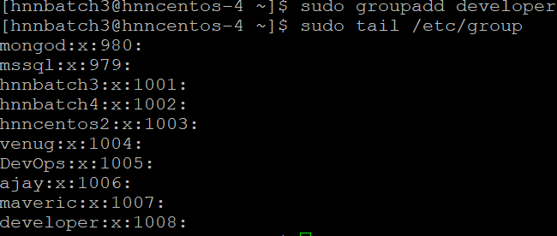

**To Modify the user**

**#usermod <options> <username>**

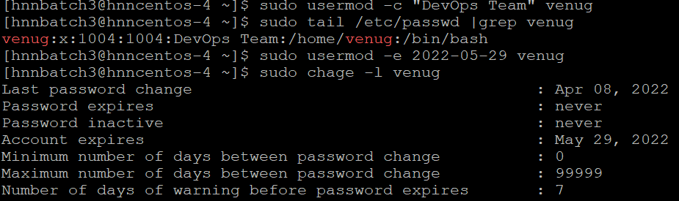

**To change user login name**

**#usermod -l <old username> <new Username>**

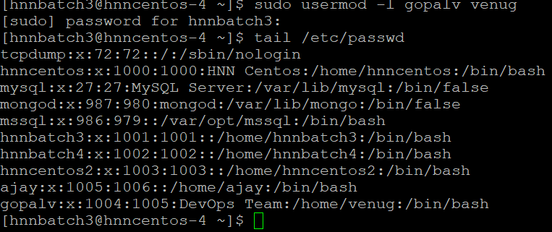

**To lock and unlock the user**

**#usermod -L <username> ------ Lock**

**#usermod -U <username> ----- unlock**

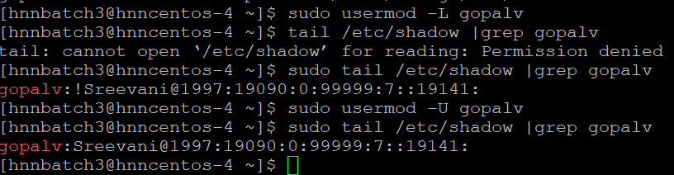

**To set password**

**#usermod -p <password > <username>**

**#passwd <username>**

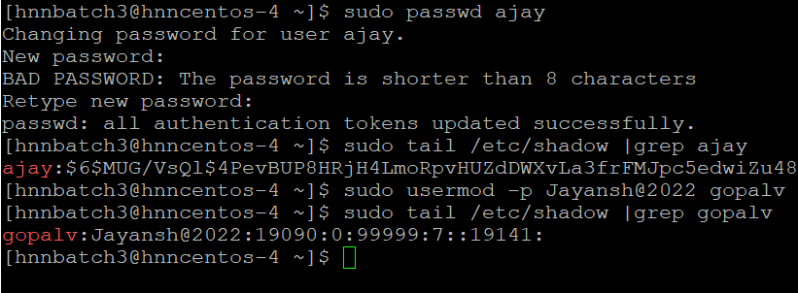

**Scheduling Jobs**

**Crontab**

**To check the cron jobs for particular user**

**#crontab -l -u gopalv**

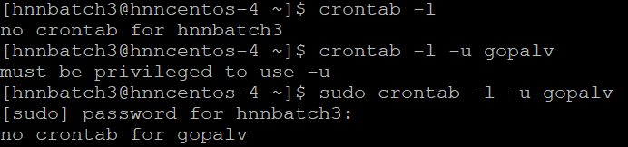

**Schedule a job so that user “gopalv” should get a mail regarding meeting on 27th October at 2:25 PM**

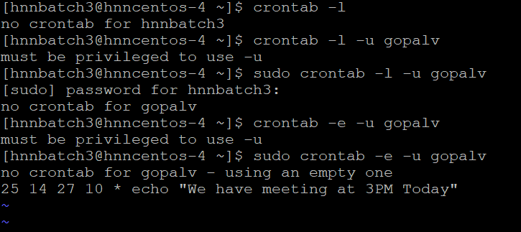

**Schedule a job using at to get a mail regarding meeting at 11:30am**

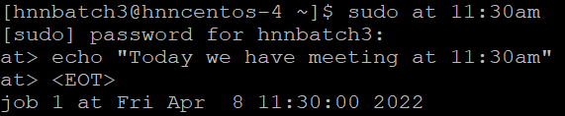

**Filesystem**

**To check available disk in the system**

**#fdisk -l**

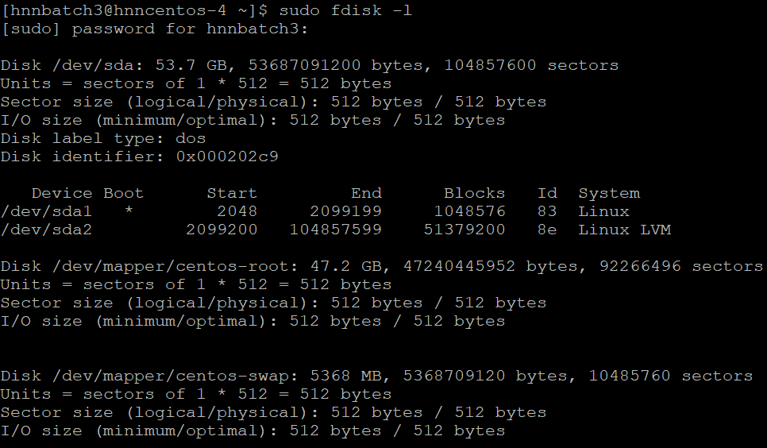

**To create partitions**

**#fdisk /dev/sda**

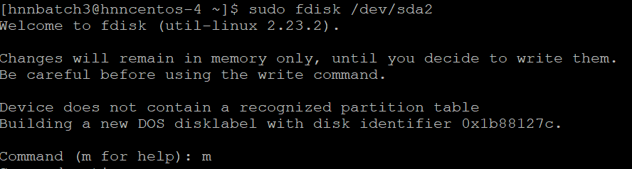

**LVM (Logical Volume Management)**

This is an alternative method of managing storage systems then the traditional partition based one. In LVM, instead of creating partitions, you create a logical volumes, and then you can easily mount those volumes in your file system

Commands

**#fdisk /dev/sdc**

First you need to do partition and change the hex code from 83 to 8e

Create a PV on newly created partition

**#pvcreate <pvname> ---🡪 #pvcreate /dev/sdc1 #pvs #pvdisplay**

Create VG on newly created PV’s

**#vgcreate <vgname> <pvname> / #vgs #vgdisplay**

Create LV on newly created VG

**#lvcreate -L +<size> <lvname> <vgname> / #lvs #lvdisplay**

Adding filesystem

**#mkfs.ext4 /dev/vgname/lvname**

Mounting

**#mkdir <dirname>**

**#mount /dev/vgname/lvname <dirname>**

For permanent mount make an entry in **fstab** file

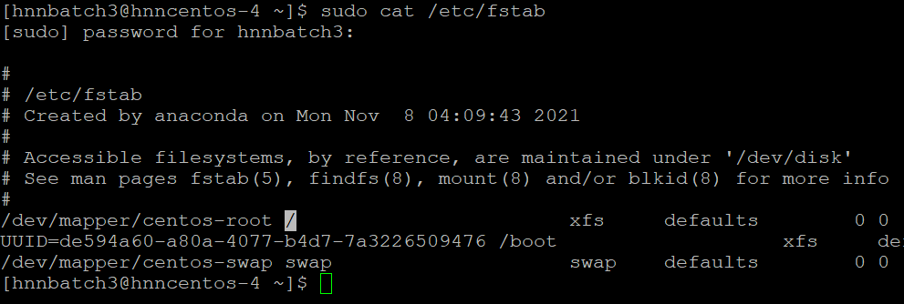

To extend VG

**#vgextend <vgname> <pvname>**

To extend LV

**#lvextend -L +<size> /dev/vgname/lvname**

**#resize2fs /dev/vgname/lvname**

To reduce LV

We can’t reduce LV in online, required down time

Unmount the filesystem

Organize the data

**#umount <mountpoint name>**

**#e2fsck -f /dev/vgname/lvname**

**#resize2fs /dev/vgname/lvname 300M**

**#lvreduce -L – 200M /dev/vgname/lvname**

File System in Linux

When we install the Linux operating system, Linux offers many file systems such as **Ext, Ext2, Ext3, Ext4, JFS, XFS,**  and **swap**.

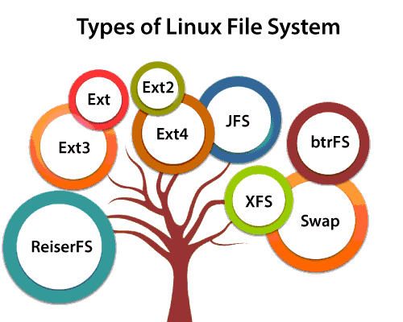

**EXT**:

The file system Ext stands for Extended File System. The Ext file system is an older version, and is no longer used due to some limitations.

**Ext2**:

Ext2 is the first Linux file system that allows managing two terabytes of data.

**Ext3**: It is an upgraded version of Ext2 and contains backward compatibility. The major drawback of Ext3 is that it does not support servers because this file system does not support file recovery and disk snapshot.

**Ext4**: It is the faster file system among all the Ext file systems. It is very compatible option for the SSD(Solid state drive) disks, and it is the default file system in Linux distribution.

**SWAP:** Swap space in Linux is used when the amount of physical memory is full. If the system needs more memory resources and the RAM is full, inactive pages in memory are moved to the swap space.

To create a swap partition with swap file system

**#mkswap <partition name>**

To activate the swap space

**#swapon <partition name>**

**RPM**

To check all the packages installed on the system

#rpm -qa

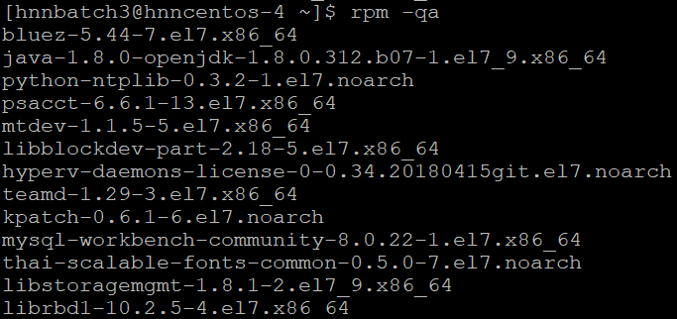

To install the package the syntax is

# rpm – ivh <packagename>

#rpm -ivh –test <packagename>

**I/O Redirections**

**Output**

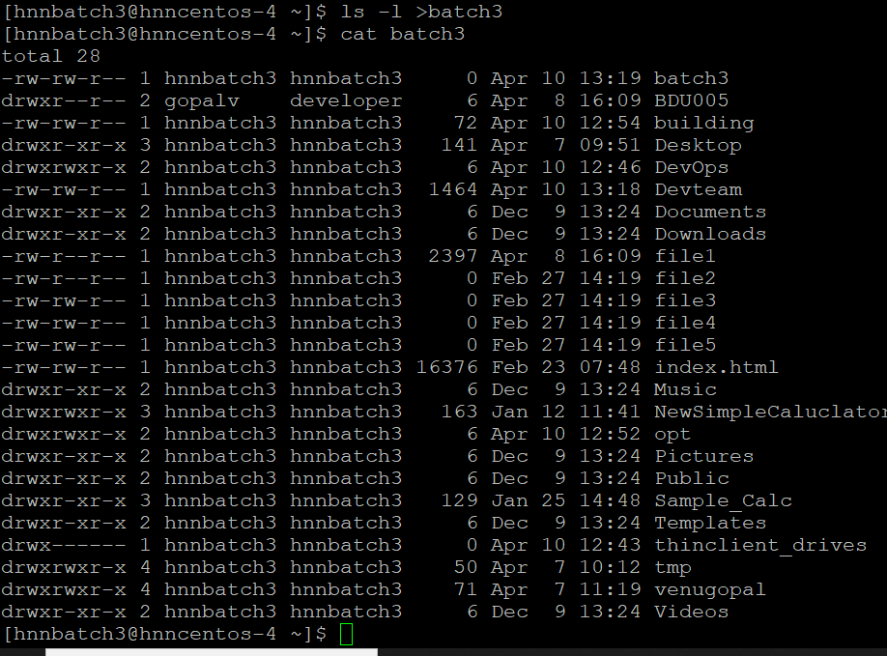

**Input**

If you want to attach file to mail

#mail -s “News Today” <mailID> < New Flash

To redirect the error message

**#telnet localhost 2> venu.err**

>& ----🡪 Which writes the output from one file to the input of another file.

**#ls Documents venu > dirlist 2>&1**

**Tar and gzip**

To backup the file using tar

#tar -cvf <destination location> <source file>

To check the size tar file

#du -h <file.tar>

To apply gzip on tar file

#gzip <file name>

To untar a file

#tar -xvf <filename>

To unzip a file

#gunzip <filename>

SSH

To generate ssh key pair

#ssh-keygen

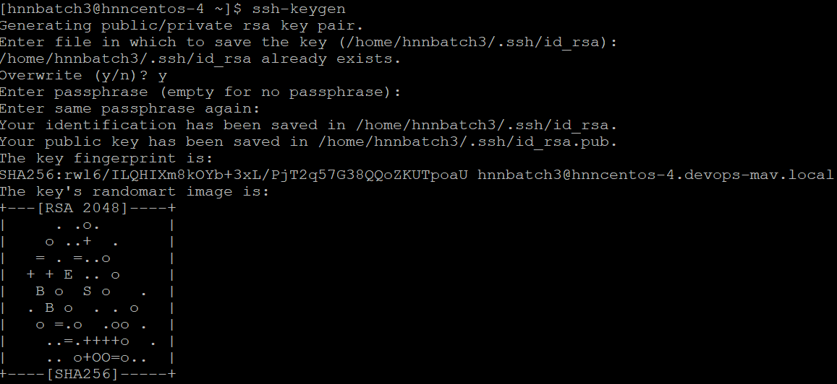

#ssh-copy-id -i <publickey location> <client IP>

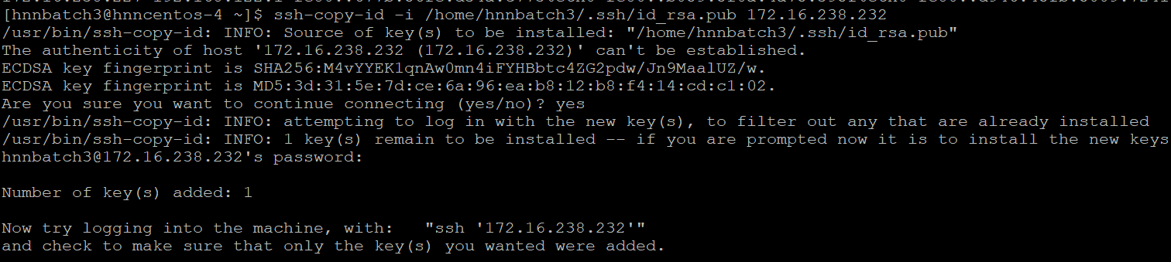

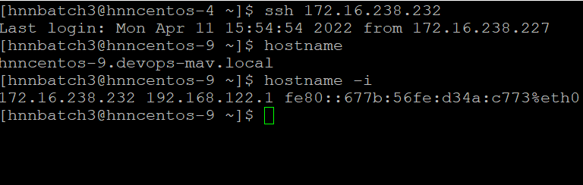

**SCP—Secure copy**

To copy a file using SCP to remote machine from source machine

**#scp <filename> <remote machine IP>: <location to copy the file>**

To copy a file using SCP to source machine from remote machine

**#scp <source machine IP>: <filename> <location to copy the file>**

**RSYNC – Remote Synchronization**

To rsync a directory

**#rsync -rv -e ssh <dir name> <destination IP>: <location to copy the file>**

To compress the data and send it in archive mode use -avz instead of -rv

**#rsync -avz -e ssh <dir name> <destination IP>: <location to copy the file>**